

**MALAD KANDIVALI EDUCATION SOCIETY’S**

## NAGINDAS KHANDWALA COLLEGE OF COMMERCE, ARTS & MANAGEMENT STUDIES & SHANTABEN NAGINDAS KHANDWALA COLLEGE OF SCIENCE

**MALAD [W], MUMBAI – 64**

AUTONOMOUS INSTITUTION

(Affiliated To University Of Mumbai)

Reaccredited ‘A’ Grade by NAAC | ISO 9001:2015 Certified

**CERTIFICATE**

Name: Vrajdalal

Roll No:370 Programme:BScIT/CS Semester:III

This is certified to be a bonafide record of practical works done by the above student in the

college laboratory for the course **Hybrid Application Development(classcode:2037UCSMD)**for the partial fulfilment of Third Semester of BSc IT/CS duringthe

academic year 2020-21.

The journal work is the original study work that has been duly approved in the year 2020-21 by the undersigned.

External Examiner

Mr. Gangashankar Singh (Subject-In-Charge)

DateofExamination: (CollegeStamp)

# Class: S.Y. B.Sc. ITSem-III Roll No:370

**Subject: Hybrid ApplicationDevelopment INDEX**

|  |  |  |  |
| --- | --- | --- | --- |
| **Sr. No** | **Date** | **Topic** | **Sign** |
| **1** | **27/07/2020** | **AngularJS Data Binding** |  |
| **2** | **7/08/2020** | **AngularJS Directives** |  |
| **3** | **14/08/2020** | **AngularJS Controllers** |  |
| **4** | **25/08/2020** | **AngularJS Events** |  |
| **5** | **08/09/2020** | **Ionic Create and Build First Project** |  |
| **6** | **12/09/2020** | **Ionic Adding Cordova Android Platform** |  |
| **7** | **19/09/2020** | **IonicCreate, Generate and AddPages** |  |
| **8** | **29/09/2020** | **Ionic Use Tabs Starter Template** |  |

**Practical 1: Data Binding**

**What is Data Binding in AngularJS?**

Data-binding in AngularJS apps is the automatic synchronization of data

between the model and view components. While you could push values to and

pull values from HTML, the application is easier to write, read, and maintain if

you turn these tasks over to a binding framework. You simply declare bindings

between binding sources, target HTML elements, and let the framework do the

rest.

**CODE AND OUTPUT**

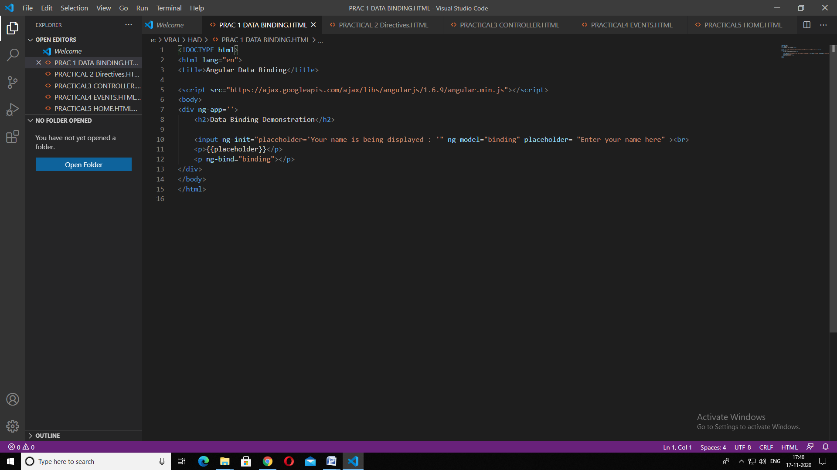

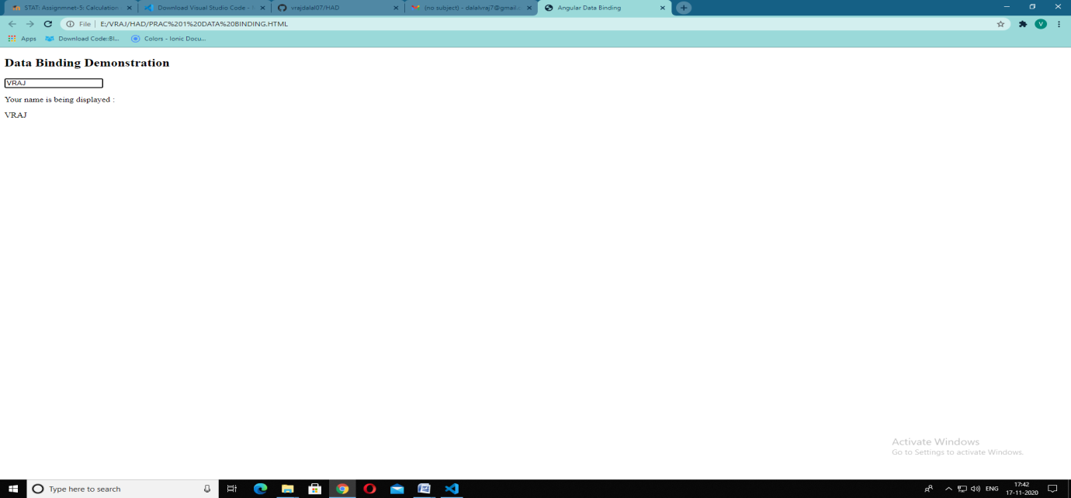

**Practical – 02**

**What are Directives in AngularJS?**

AngularJS lets you extend HTML with new attributes called Directives.

AngularJS has a set of built-in directives which offers functionality to your

applications.

AngularJS also lets you define your own directives.

**CODE AND OUTPUT**

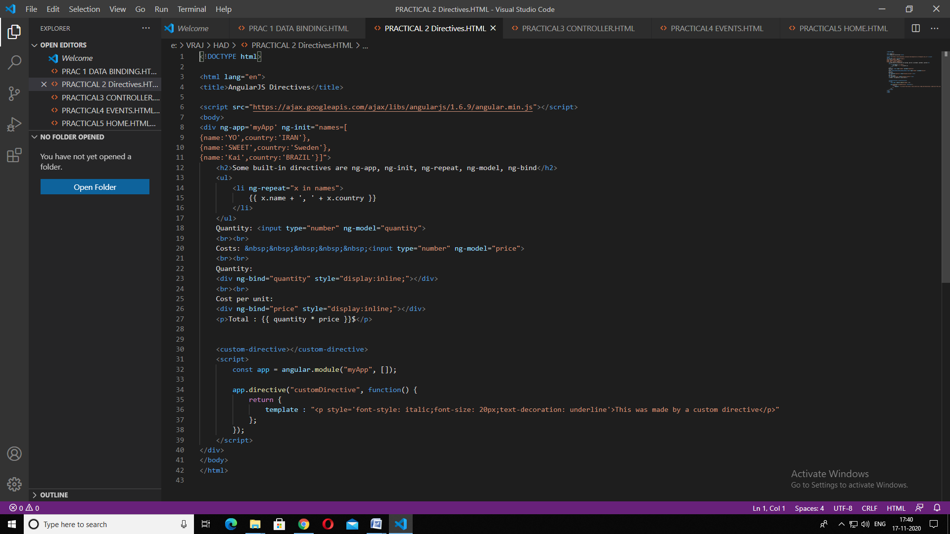

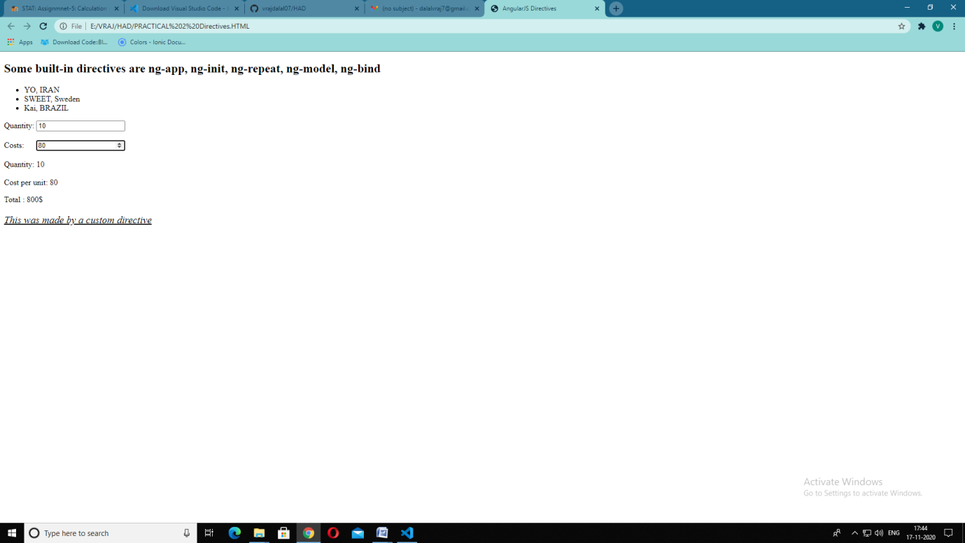

**Practical 3: Controllers**

**What are Controllers in AngularJS?**

AngularJS applications mainly rely on controllers to control the flow of data in

the application. A controller is defined using ng-controller directive. A controller

is a JavaScript object that contains attributes/properties, and functions. Each

controller accepts $scope as a parameter, which refers to the

application/module that the controller needs to handle.

**CODE AND OUTPUT**

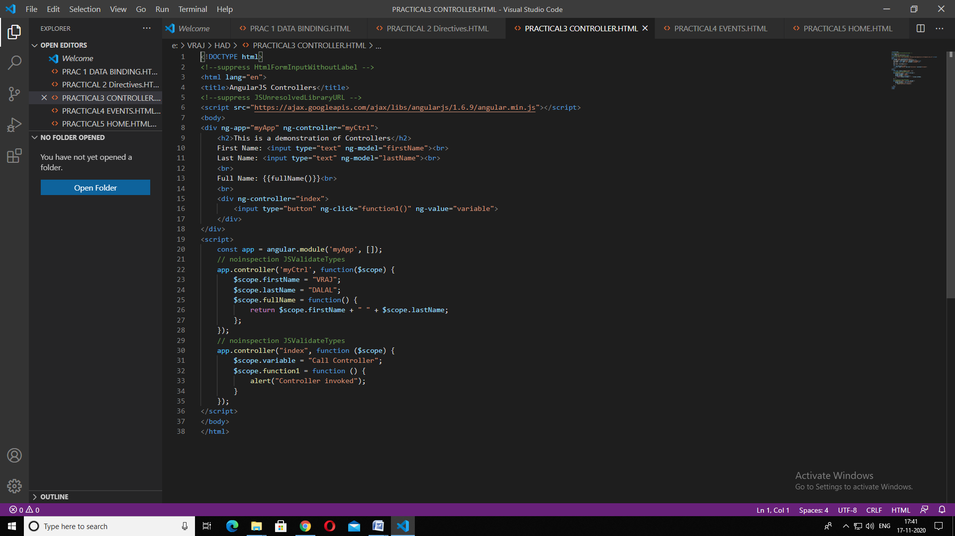

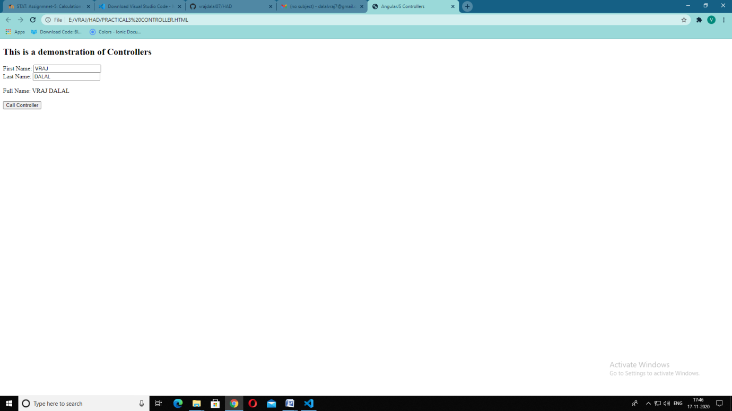

**Practical 4 - AngularJS Events**

**What are Events in AngularJS?**

AngularJS includes certain directives which can be used to provide custom

behavior on various DOM events, such as click, mouseover etc.

An AngularJS event will not overwrite an HTML event, both events will be

executed.

You can pass the $event object as an argument when calling the function. The

$event object contains the browser's event object.

**CODE AND OUTPUT**

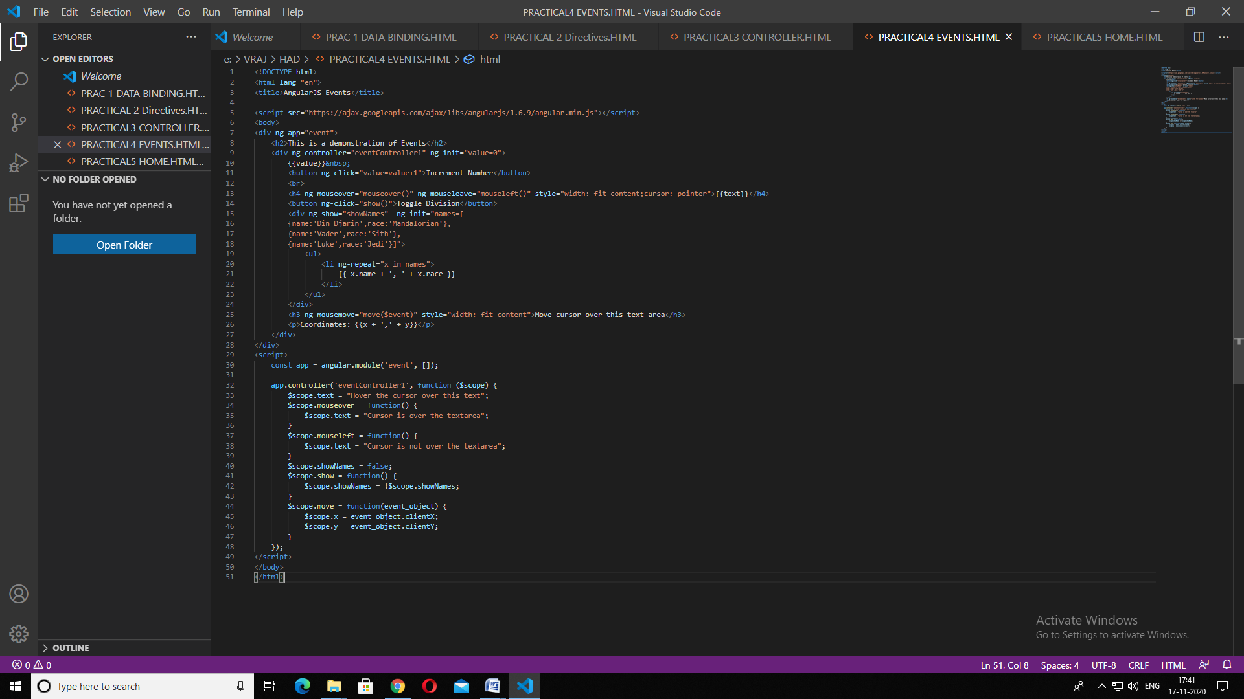

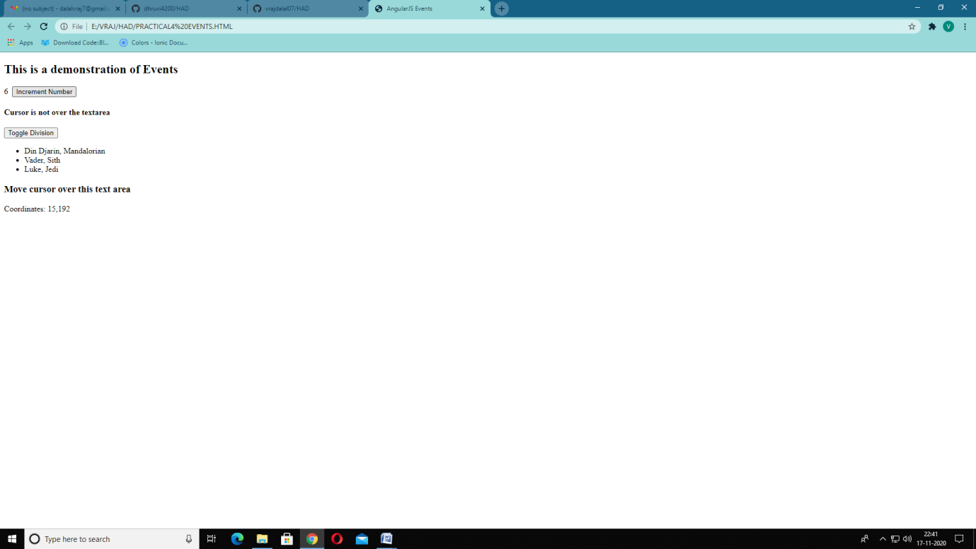

**Practical – 05**

**What is a hybrid app?**

Like native apps, run on the device, and are written with web technologies

(HTML5, CSS and JavaScript). Hybrid apps run inside a native container, and

leverage the device’s browser engine (but not the browser) to render the HTML

and process the JavaScript locally. A web-to-native abstraction layer enables

access to device capabilities that are not accessible in Mobile Web applications,

such as the accelerometer, camera and local storage. How to create and web

app in Ionic:

**Requirements:**

1.Node.js with npm in path

**Steps:**

1.Open command prompt as administrator

2.Runnpm install -g ionic

3.Create a folder for your ionic project by running md <folder_name>

4.Navigate to the folder by running cd <folder_name>

5.To create an ionic app run ionic start <app_name> blank

6.Then it will ask to choose a framework so choose Angular JS

7.Navigate to the folder by running cd <app_name>

8.Then to start running the ionic web page on the server type ionic serve

9.To access the web page go on http://localhost:8100

**Code:**

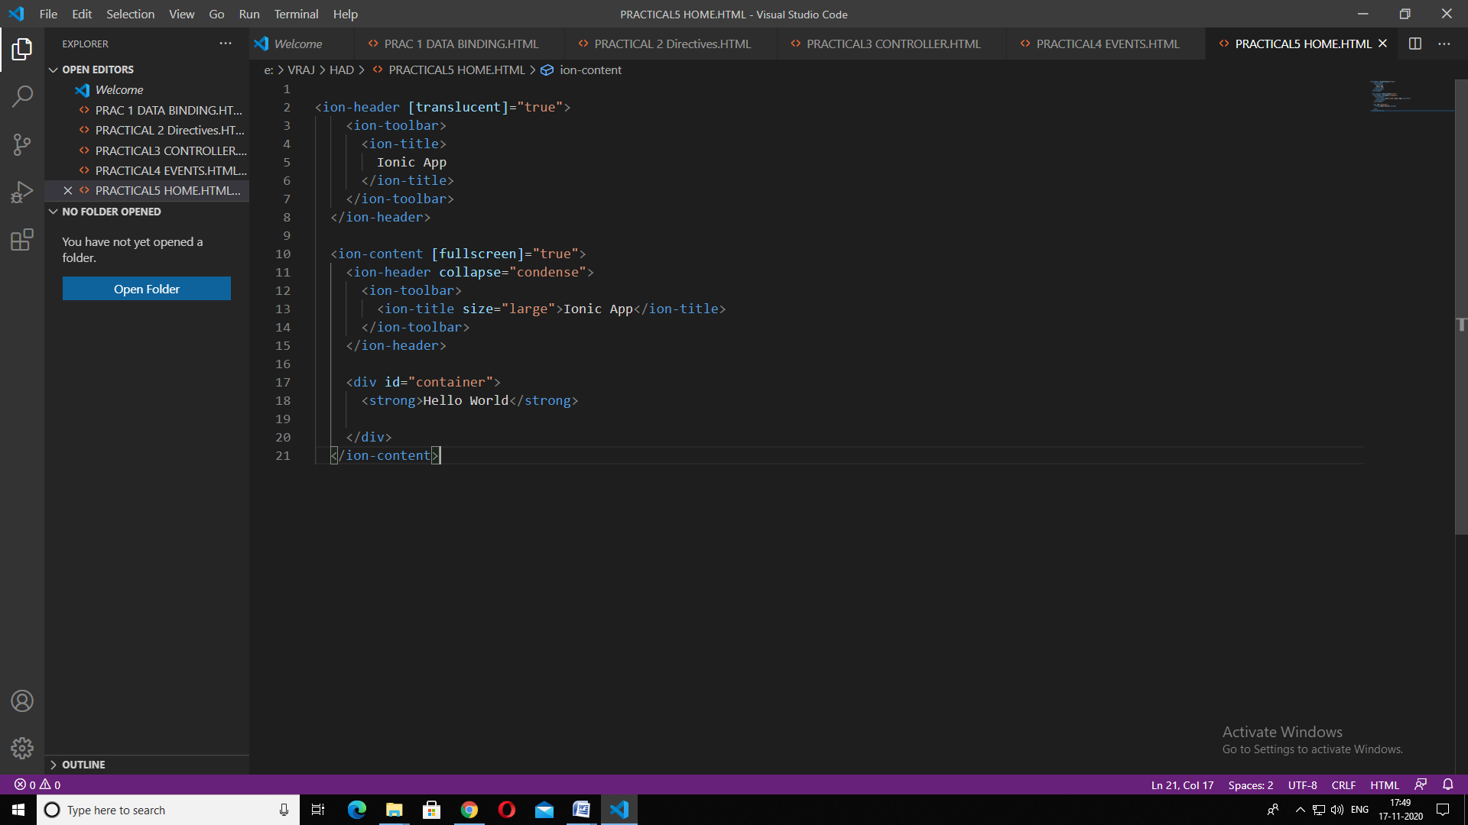



**Practical – 06**

**Ionic Adding Cordova Android**

**Platform**

**What is Cordova?**

Apache Cordova is an open-source mobile development framework. It allows

you to use standard web technologies - HTML5, CSS3, and JavaScript for crossplatform

development. Applications execute within wrappers targeted to each

platform, and rely on standards-compliant API bindings to access each device's

capabilities such as sensors, data, network status, etc.

Cordova can be used an integration for Ionic to export Ionic web apps to Native

mobile applications like an Android APK.

**Requirements:**

1.Java 8 in path and JAVA_HOME set

2.Android SDK with ANDROID_SDK_ROOT set

3.Gradle in path

**Steps:**

1.Installcordova resources by running npm install -g cordova-res

2.To add support for the Android platform run ionic cordova platform add android

3.To build a debug Android APK run ionic cordova build android

4.Install app-debug.apk in your device from {project_root}\platforms\android\app\

build\outputs\apk\debug

**Command:**





**Practical 7 :**

**Ionic Create, Generate and Add**

**Pages**

**What are Ionic Pages?**

An Ionic page is just an Angular component.

The Ionic Page handles registering and displaying specific pages based on

URLs. It's used underneath NavController so it will never have to be interacted

with directly. When a new page is pushed with NavController, the URL is

updated to match the path to this page.

Unlike traditional web apps, URLs don't dictate navigation in Ionic apps.

Instead, URLs help us link to specific pieces of content as a breadcrumb. The

current URL gets updated as we navigate, but we use the NavController push

and pop, or NavPush and NavPop to move around. This makes it much easier to

handle complicated nested navigation.

The ionic generate or ionic g command uses the Angular CLI to generate features

such as pages, components, directives, services, etc.

**Steps:**

1.Open command prompt as administrator

2.Create a folder for your ionic project by running md <folder_name>

3.Navigate to the folder by running cd <folder_name>

4.To create an ionic app run ionic start <app_name> blank

5.Then it will ask to choose a framework so choose `Angular JS``

6.Navigate to the folder by running cd <app_name>

7.To generate and add a page run ionic g page <page_name>

8.This will create a folder with all the components of your page in

{project_root}\src\app\{page_name}

9.Then to start running the ionic web page on the server type ionic serve

10.To access the web page go on http://localhost:8100/{page_name}

**Code &Output :**

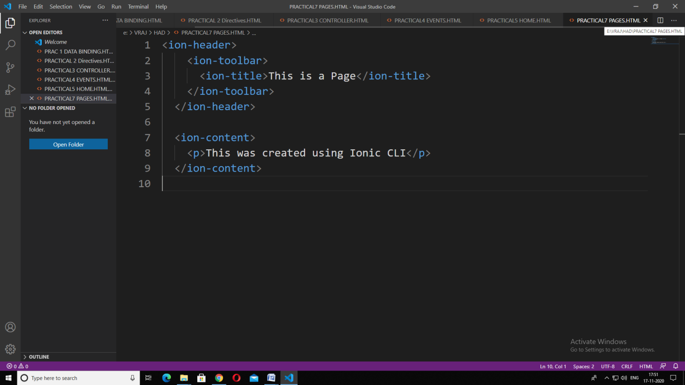

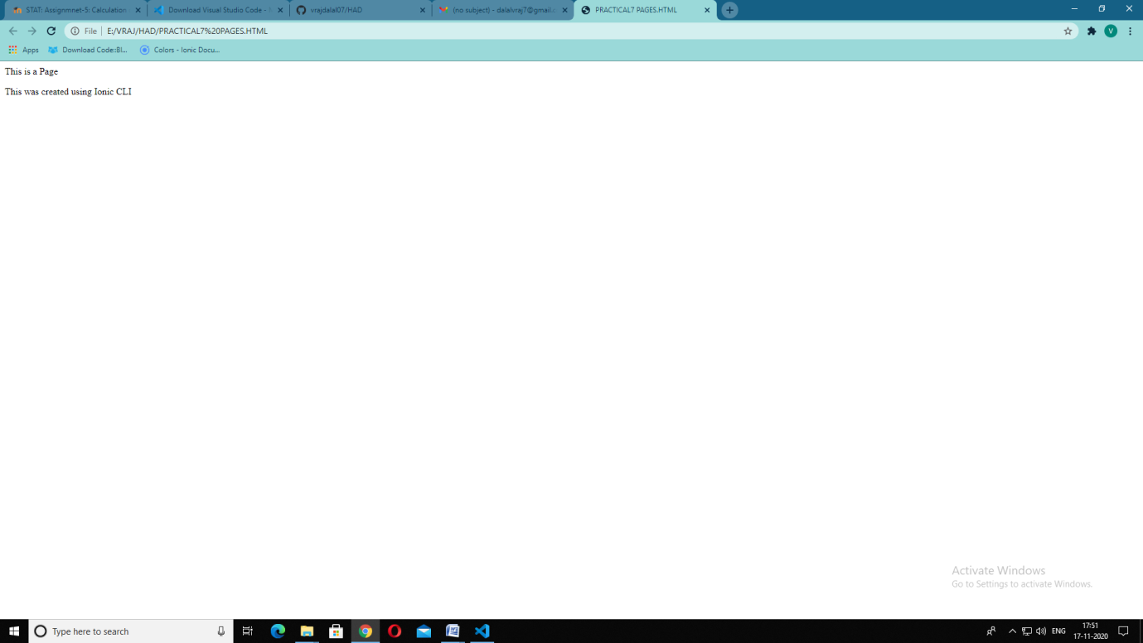

**Practical 8 :**

**Ionic Use Tabs Starter Template**

**What are Ionic Starter Templates?**

Ionic Starter Templates are ready-to-go starter packs for your next Ionic app.

Between all project types, there are three templates available:

•tabs: A tab based layout

•sidemenu: A sidemenu based layout

•blank: An empty project with a single page

We wil be using 'tabs' in the practical

**Steps:**

1.Open command prompt as administrator

2.Create a folder for your ionic project by running md <folder_name>

3.Navigate to the folder by running cd <folder_name>

4.To create an ionic app run ionic start <app_name> tabs

5.Then it will ask to choose a framework so choose Angular JS

6.Navigate to the folder by running cd <app_name>

7.Then to start running the ionic web page on the server type ionic serve

8.To access the web page go on http://localhost:8100

**Code:**

**Commands:**

**Output:**





